Experiment No: - 07
Experiment Name:- Static Routing: - Configuring Static Routes
Working Procedure:
Types of routing:
- Default
- Static
- Dynamic

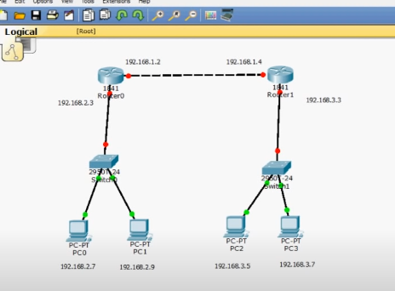
Router 0:
Router 0 -> Config-> FastEthernet 0/0
Make sure port status is “ON”
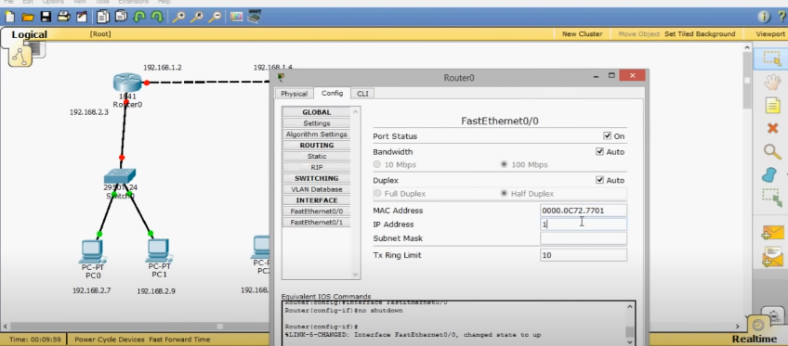
Now assign IP Address
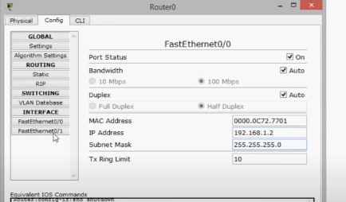
Now do similar procedure for FastEthernet 0/1
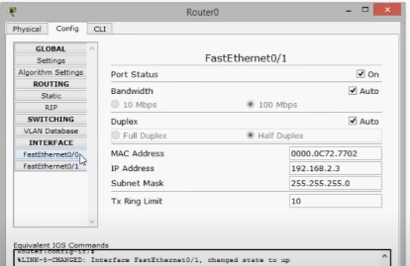
Router 1:
Now do the same thing for the router 1 as you do for router 0
FastEthernet 0/0
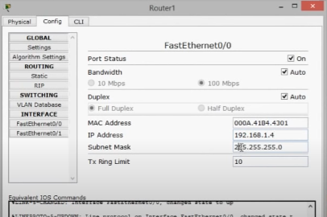
FastEthernet 0/1
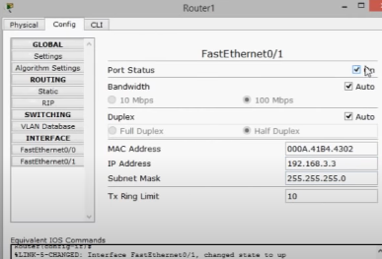

Now Configure the PC’s
Click on PC -> Desktop -> IP Configuration -> Assign IP in Static

PC 0:
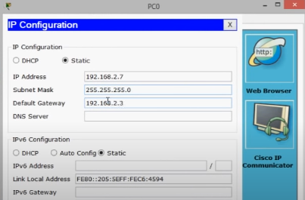
PC 1:
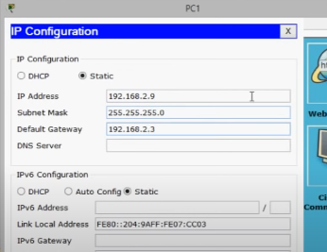
PC 2:
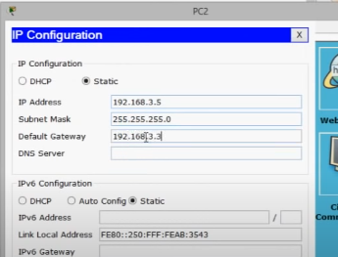
PC 3:
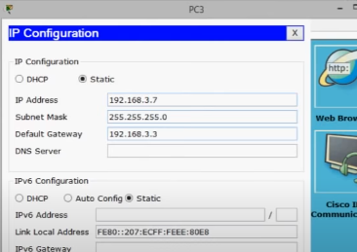
Ping:
It is successful in the same network but failed in across the network
For Example:
Between PC 0 and PC 1 is successful
But PC 2 and PC 0 is Failed

Our goal is to make sure all PC’s able to communicate with each other
STATIC Routing:
Router 0:
Click on Router 0 -> config -> Static -> Here put in the other network address
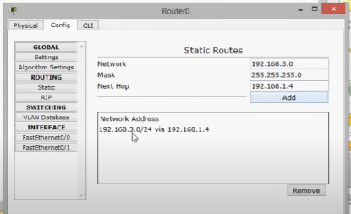
Now do the same for Router 1:
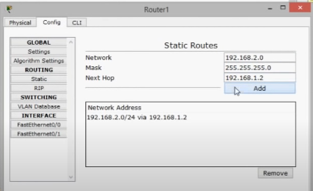

Static Routing using CLI:
Use “Ip route network-ip subnet-mask next-hop” command
